AIM for Business Flows
DO.080 Technical Reference Manual
LSL
E Business Suit and APEX

Author: Sayuru Jayasinghe
Creation Date: March 7, 2006
Last Updated: July 5, 2019
Document Ref: TRM.0001
Version: V1

Title, Subject, Last Updated Date, Reference Number, and Version are marked by a Word Bookmark so that they can be easily reproduced in the header and footer of documents. When you change any of these values, be careful not to accidentally delete the bookmark. You can make bookmarks visible by selecting Tools->Options…View and checking the Bookmarks option in the Show region.

Approvals:
Amila Kodituwakku
Project Manager
To add additional approval lines, press [Tab] from the last cell in the table above.
You can delete any elements of this cover page that you do not need for your document. For example, Copy Number is only required if this is a controlled document and you need to track each copy that you distribute.
 Copy Number _____

Document Control

Change Record
1
Date | Author | Version | Change Reference
14-Apr-19 | Sayuru Jayasinghe | V1 | No Previous Document
29-Apr-19 | Sayuru Jayasinghe | V2 | Added APEX developed applications

Reviewers

Name | Position

Distribution

Copy No. | Name | Location
 | Library Master | Project Library
 |  | Project Manager
The copy numbers referenced above should be written into the Copy Number space on the cover of each distributed copy. If the document is not controlled, you can delete this table, the Note To Holders, and the Copy Number label from the cover page.

Note To Holders:
If you receive an electronic copy of this document and print it out, please write your name on the equivalent of the cover page, for document control purposes.
If you receive a hard copy of this document, please write your name on the front cover, for document control purposes.
Contents
Document Control ii
Chapter 1 Intermediate Server 2
Chapter 2 Oracle E Business Suit 3
Chapter 3 APEX 4
Appendix 5
Open and Closed Issues 6
Open Issues 6
Closed Issues 6

To update the table of contents, put the cursor anywhere in the table and press [F9]. To change the number of levels displayed, select the menu option Insert->Index and Tables, make sure the Table of Contents tab is active, and change the Number of Levels to a new value.

Chapter
1 Intermediate Server
This Chapter consists with Oracle APEX and it’s database and application.
Test\Dev. Environment
SLT Cloud Test Databse: 124.43.130.47/1522/APX/apex
TEST Instance Services:
https://124.43.130.47:8443/ords/apex/oauth/token
Client ID: 4hQFkh4CFOW35hhkT_NZuw..
Client Secret: s6q7Tmucbf98mfQvvw4B2g..
Token Name: Client 1
Steps for pbsa ssl certificate failures and OAuth 2.0 authentication:
- Execute in Linux bash “sh test.sh”
- Run below procedures (no parameters) APEX.XXPBSA_HO_REQUEST_PBSA_TOKEN and APEX.XXPBSA_REQUEST_PBSA_TOKEN

PBSA POS Production Environment
https://122.255.14.205:31040/api/token
http://122.255.14.205:31041/api/token
or
https://192.168.16.12:31040/api/token
Client ID: ck_9m7oivisw3wqrodlnqquk4bknbmkrcmynhhvq
Client Secret: cs_2tlvknc0sp5kyw9tpgx7rak9ko5nwh6gq4k81
wallet location - file:/home/oraapex/wallet13
PBSA POS Test Environment
https://support.pbsa.com.au:31040/api/token
Client ID: ck_2kh7x79yhyz759njnorad3qmradn7oeljdavj
Client Secret: cs_fpnmhhsna6xj9jzrmipd8i9l9hw7viy5kjzco
wallet location - file:/home/oraapex/wallet

Oracle APIs (I - LIVE)
https://124.43.130.47:8443/ords/apex/lsl/v1/stores/
https://124.43.130.47:8443/ords/apex/lsl/v1/purchase-request/
https://124.43.130.47:8443/ords/apex/lsl/v1/supplier-return-requests/
https://124.43.130.47:8443/ords/apex/lsl/v1/products/
Oracle APIs (II - TEST)
https://124.43.130.47:8443/ords/apex/lslmodule9/v1/purchase-request/
https://124.43.130.47:8443/ords/apex/lslmodule2/v1/supplier-return-requests/
https://124.43.130.47:8443/ords/apex/lslmodule7/v1/store/
https://124.43.130.47:8443/ords/apex/lslmodule5/v1/products/
Log Management
  - PBSA POS log (monolithic service)
head office-api
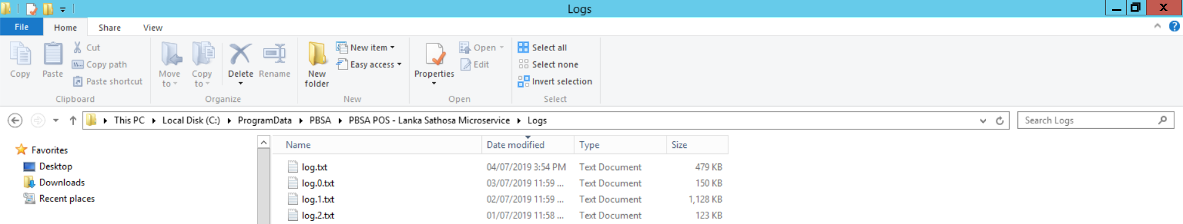
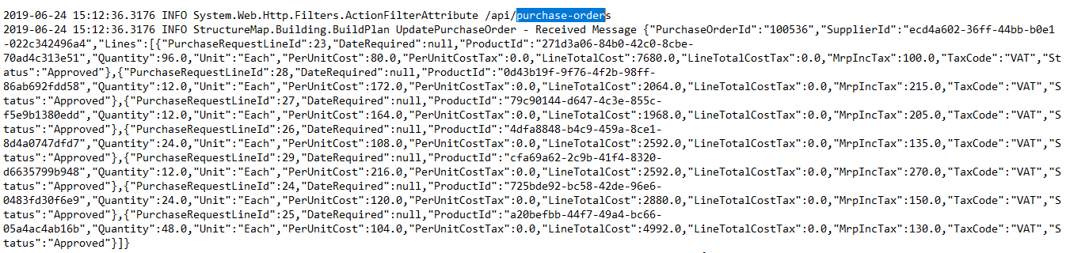

oracle-api
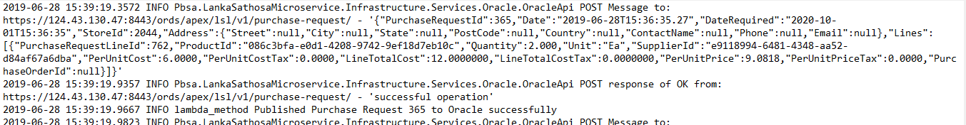

outlet-api
C:\Users\Pos12\AppData\Local\PBSA\PBSA POS\Logs
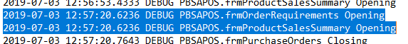

  - Oracle logs (tomcat server)
head office-api
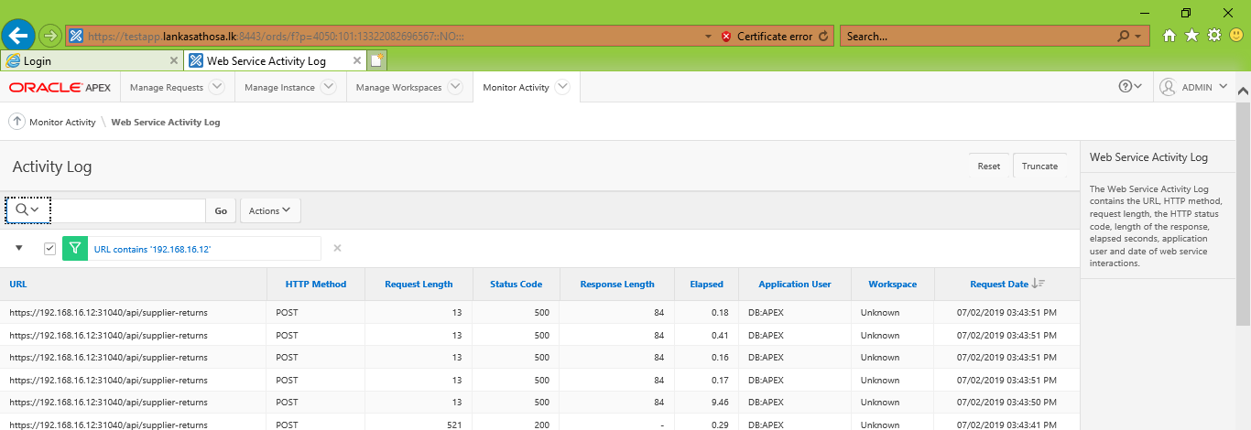
oracle-api
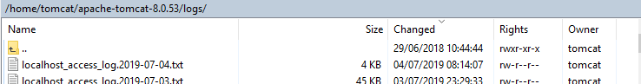

outlet-api
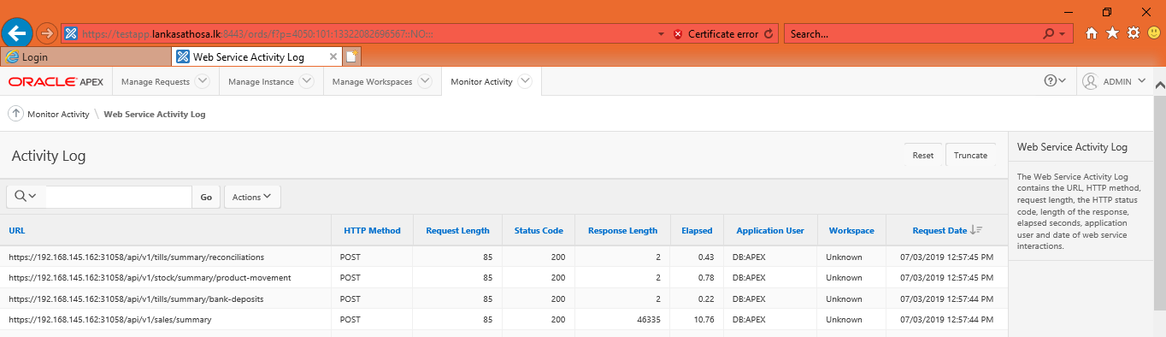

Use this section to divide your document into chapters.
The chapter number above is a Word Sequence field that automatically updates to reflect the correct chapter number when you have multiple chapters in your document.
Also consider dividing your document into sections by inserting a section break before each chapter. You can also include the current chapter number in captions and page numbers using by inserting a field (Insert->Field…) with the contents:
Seq Chapter \c
For more information, search for “Sequence” in Word for Windows help.

Chapter
2 Oracle E Business Suit
This Chapter consists with Oracle E Business Suit and it’s database and application.
SLT Cloud Test Databse: 124.43.130.47/1546/TEST/apps
SLT Cloud Test Application: http://testapp.lankasathosa.lk:8025

Custom Configuration Steps:
- after new store persisted in APEX need to update\add flex field value set

Email Server Lanka Sathosa
Oracle EBS oracleebs@lankasathosa.org
R#a|$onofM0n761

POP 3 mail.lankasathosa.org
SMTP mail.lankasathosa.org

Chapter
3 APEX
This Chapter consists with Oracle APEX and it’s database and application.
SLT Cloud Test Application:
Administrator:
INTERNAL\ADMIN\Manager#789
XXLSL\ADMIN\1qaz2wsx@
https://testapp.lankasathosa.lk:8443/ords

Applications:
Supplier Return Request Approval: https://testapp.lankasathosa.lk:8443/ords/f?p=101
Purchase Request Approval: https://testapp.lankasathosa.lk:8443/ords/f?p=102
Credit Sales Upload Application: https://testapp.lankasathosa.lk:8443/ords/f?p=103

Appendix

Oracle sqldeveloper
Java 1.4+ compatible web browser

Open and Closed Issues
Add open issues that you identify while writing or reviewing this document to the open issues section. As you resolve issues, move them to the Closed Issues section and keep the issue ID the same. Include an explanation of the resolution.
When this work product is complete, any open issues should be transferred to the project- or process-level Issue Log and managed using a project level Issue Form. In addition, the open items should remain in the Open Issues section of this work product, but flagged in the Resolution column as being transferred.

Open Issues

ID | Issue | Resolution | Responsibility | Target Date | Impact Date
1 | Production credentials | after DBA configuration | KPMG DBA | 30-Apr-2019 | 30-Apr-2019

Closed Issues

ID | Issue | Resolution | Responsibility | Target Date | Impact Date
1 | SLT Cloud migration | Network configuration by LSL and SLT | SLT\LSL | 30-Nov-2019 | 30-Nov-2019

